## rubrics table

IMPORTANT! This field name has two spaces between **JUICE** and **module id.** You must name it this way or Publish Search will not work.

## Fields

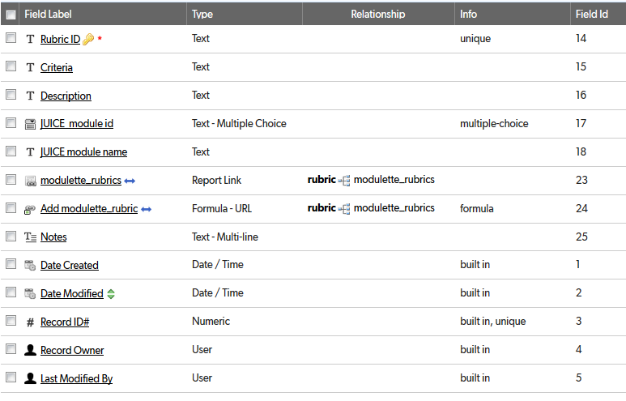

## Relationships

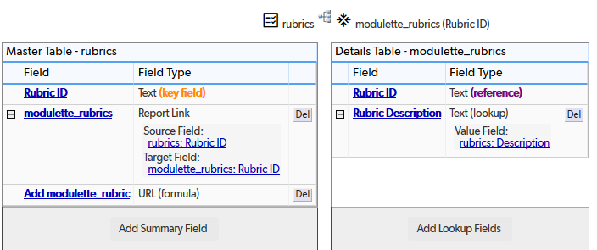

## Field settings

Note: Built-in fields use the default settings

Rubric ID 3

Criteria 5

Description 7

JUICE  module id 8

JUICE module name 10

modulette_rubrics 12

Add modulette_rubric 13

Notes 15

# Rubric ID

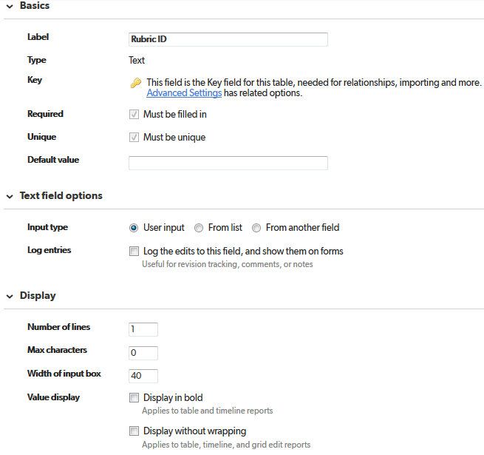

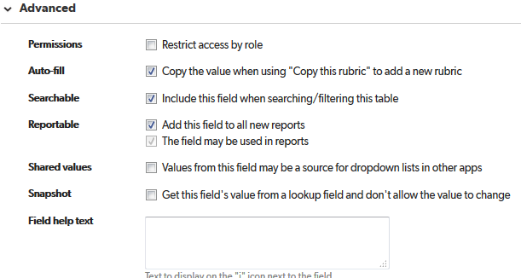

# Criteria

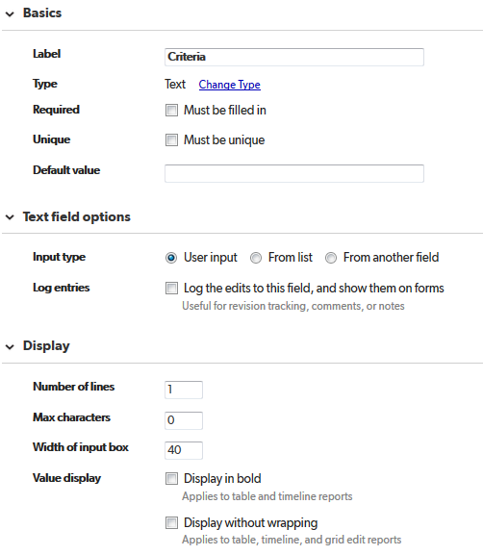

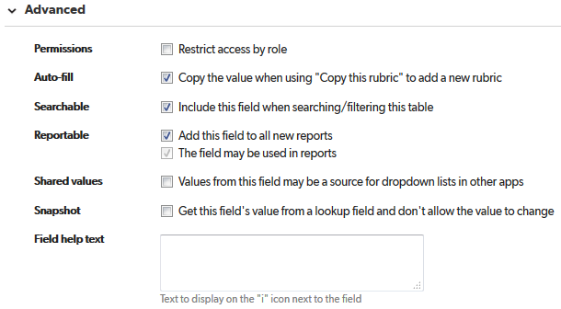

# Description

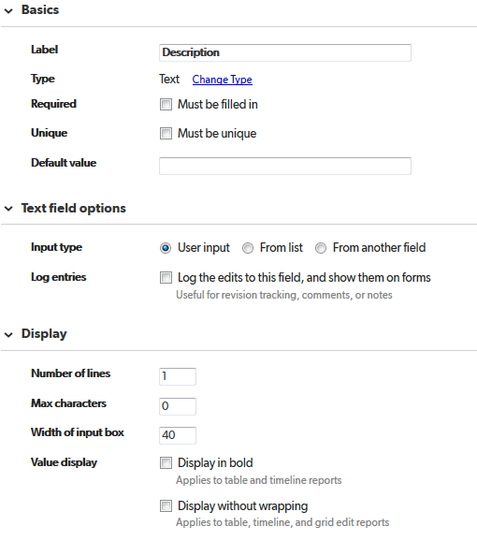

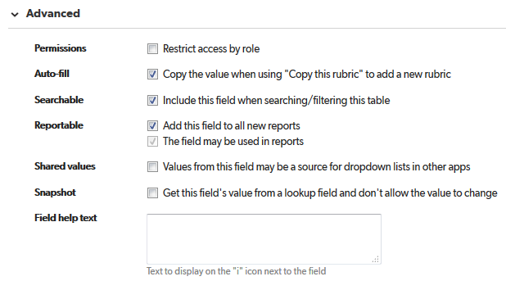

# JUICE  module id

IMPORTANT! This field name has two spaces between **JUICE** and **module id.** You must name it this way or Publish Search will not work.

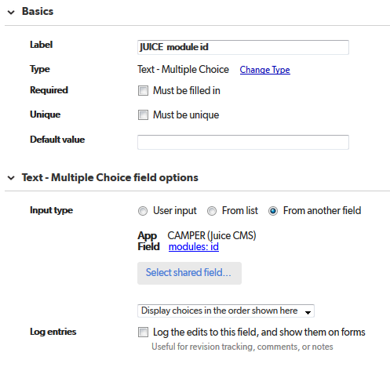

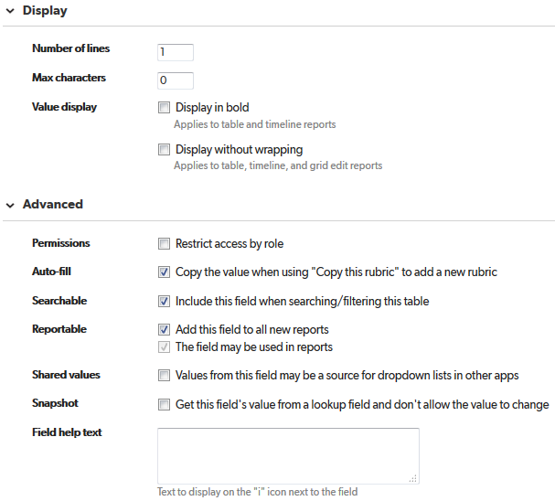

# JUICE module name

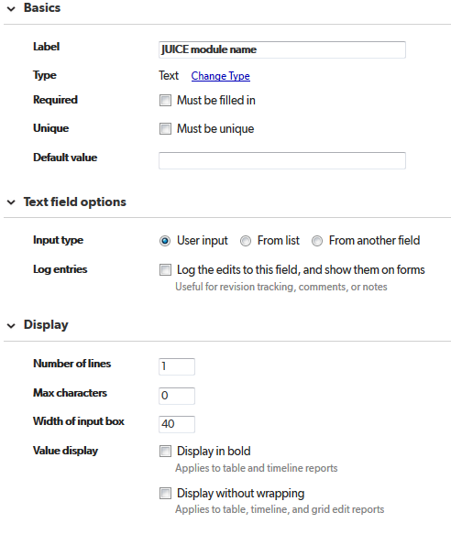

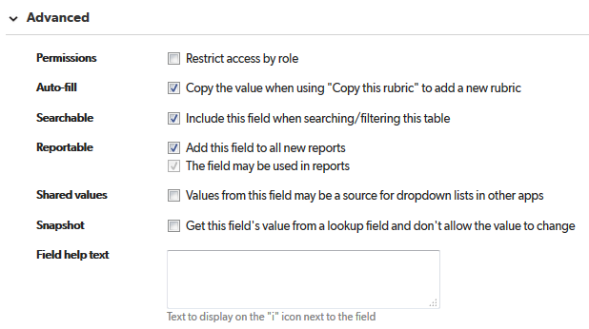

# modulette_rubrics

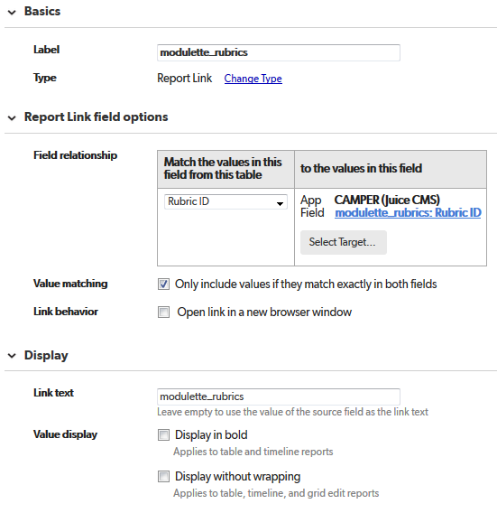

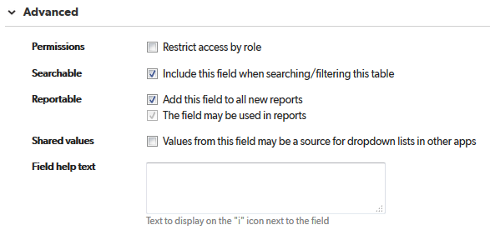

# Add modulette_rubric

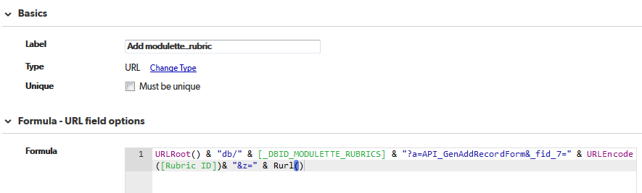

URLRoot() & "db/" & [_DBID_MODULETTE_RUBRICS] & "?a=API_GenAddRecordForm&_fid_7=" & URLEncode ([Rubric ID])& "&z=" & Rurl()

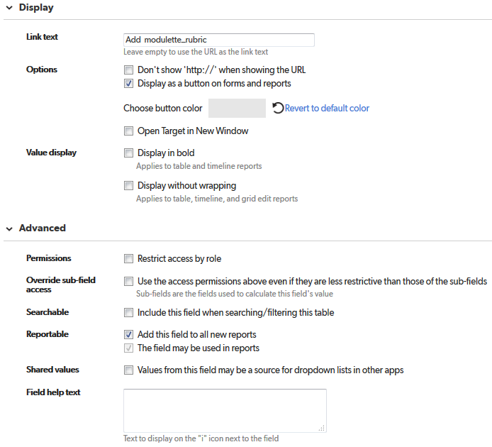

# Notes

